Name: ____________________________________________

Now that we’ve analyzed one specific basketball play, you’ve learned how to use speed graphs to answer questions about players’ movements. For each problem below, use the speed graph to answer the questions next to it.

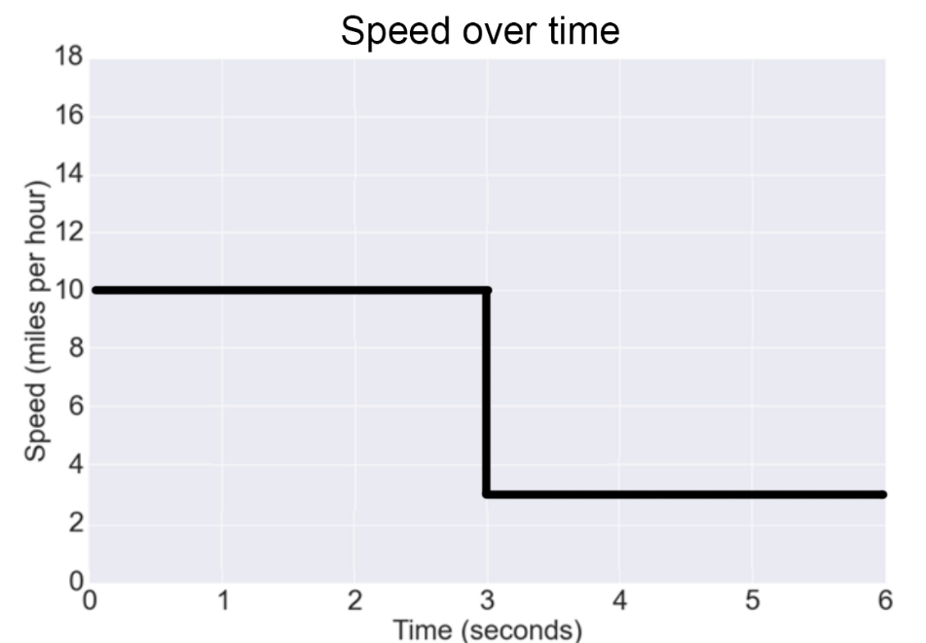Problem 1

How fast is the player running at time = 2 seconds?

___________________________

How fast is the player running at time = 4 seconds?

___________________________

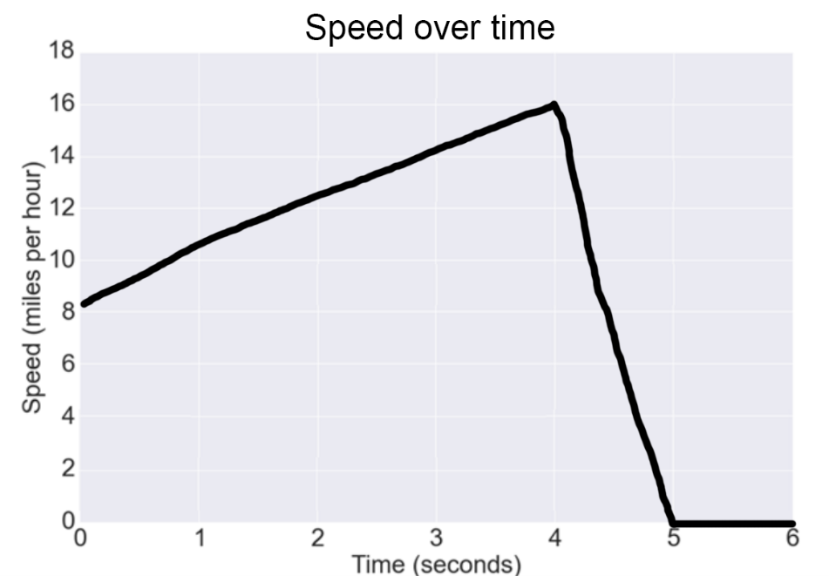Problem 2

At what time does the player start slowing down?

___________________________

At what time does the player stop moving?

___________________________

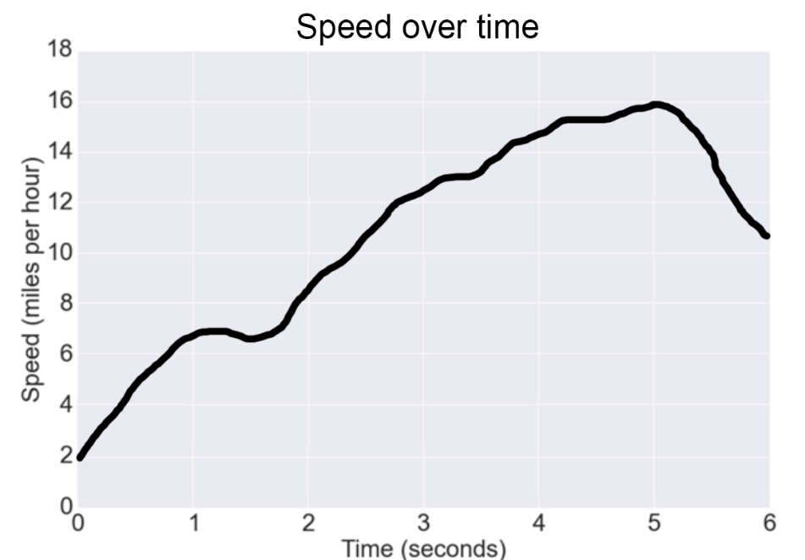Problem 3

What is the fastest speed this player moves during this play?

___________________________

At what time is the player moving that fast?

___________________________

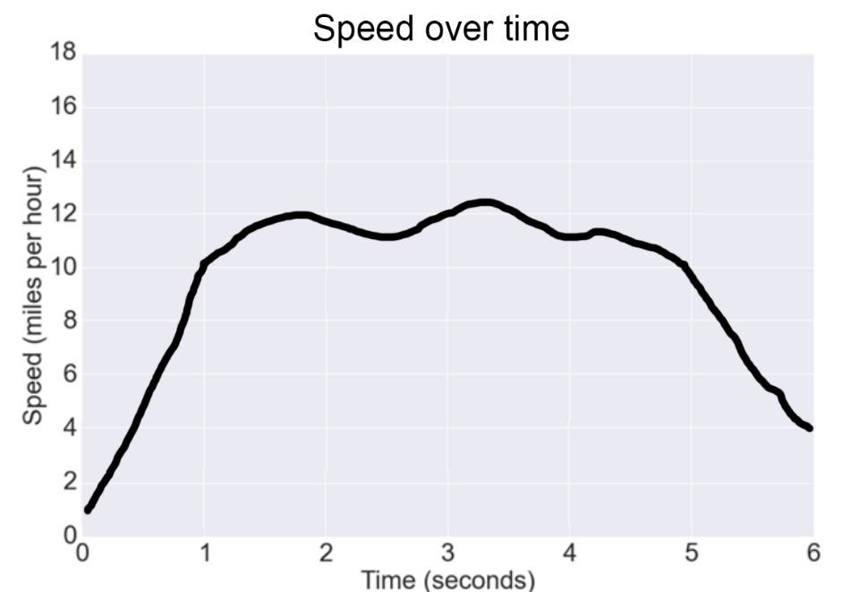Problem 4

When does the player first start running ten miles per hour?

___________________________

For how many seconds is the player running at least ten miles per hour?

___________________________

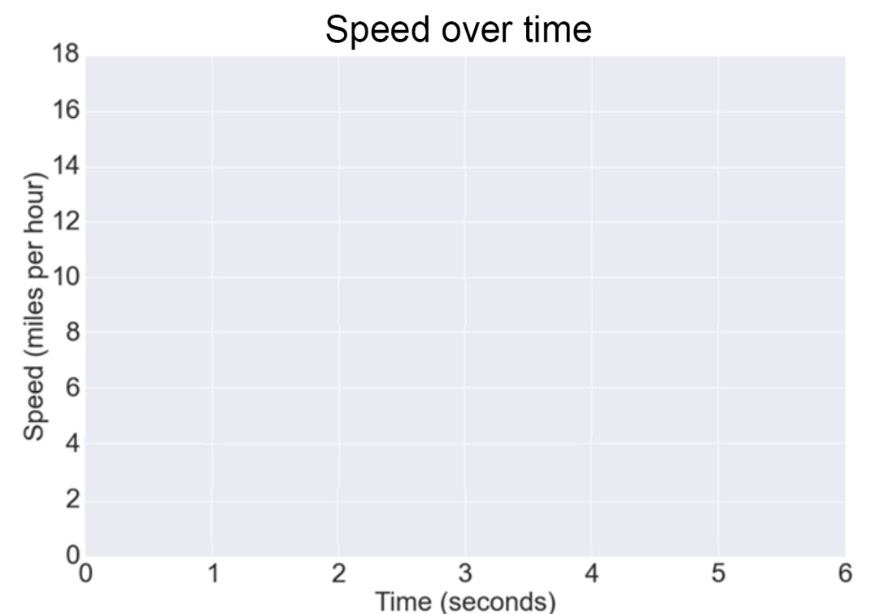

Problem 5

For this last problem, instead of analyzing a speed graph, you’re going to **draw one**.

Draw a speed graph in which the player starts at rest (zero miles per hour), reaches twelve miles per hour three seconds in, and then slows to five miles per hour at the end of the play (at six seconds).

There are many right answers!